Diode Circuits HW 3 (30 points)
(jas, Diode Circuits HW3.docx, 10/16/2024)
Clearly indicate answers and include units for numeric answers, using 3 or 4 significant figures. Show at least the major steps of your work so that if necessary partial credit can be awarded.
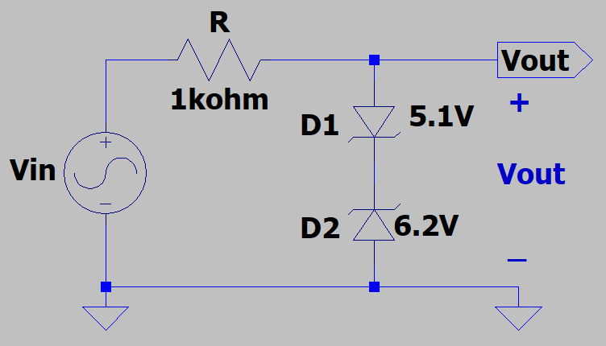
- For the adjacent biased parallel clipper circuit, determine the most positive (V_{out_max}) and the most negative (V_{out_min}) output voltages possible assuming the Simplified Diode Model, i.e., 2nd Approximation, with V_{K} = 0.7 V for a forward biased diode. (4 Points, 2 points each.)

$V_{out_max}→$ D1 forward, D2 reverse
$V_{out_max}=0.7 V+6.2 V=6.9 V$

V_{out_max} = 6.9 V

$V_{out_min}→$ D1 reverse, D2 forward
$V_{out_max}=-0.7 V+-5.1 V=-5.8 V$

V_{out_min} = -5.8 V

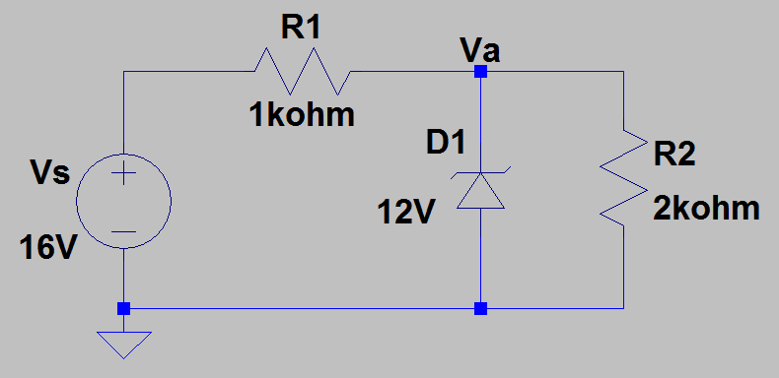
- For the adjacent circuit, Zener diode D1 has a reverse breakdown voltage of 12 V.

- Using hand calculations, determine the current I_{Z} through Zener diode D1.
(4 points.)

Without the diode, $V_{a}=V_{s}\left(\frac{R2}{R1+R2}\right)=\frac{2}{3}*16V=10.67V$
10.67V < 12V, so Zener breakdown not reached. The diode acts like an open.
$$I_{z}=0 A$$

- Determine the power dissipated by the Zener diode D1. (2 Points.)
$P_{z}=0 A$, $because P=VI and I_{z}=0 A$

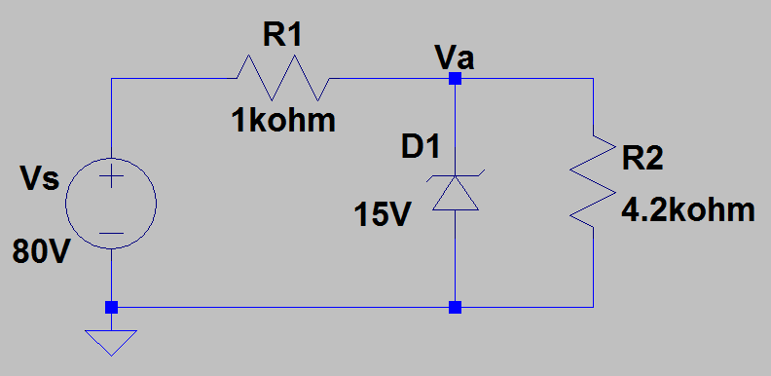
- For the adjacent circuit, Zener diode D1 has a reverse breakdown voltage of 15 V.

- Using hand calculations, determine the current I_{z} through Zener diode D1.
(4 points.)

Without D1, $V_{a}=V_{s}\left(\frac{R2}{R1-R2}\right)=80V\left(\frac{4.2}{5.2}\right)=64V$
Zener breakdown: $V_{a}=15 V$
$$I_{R1}=\frac{80-15 V}{1000Ω}= 65 mA$$
$$I_{R2}=\frac{15 V}{4.2*{10}^{3}Ω}= 3.57 mA$$
$$I_{Z}=I_{R1}-I_{R2}=61.4 m$$
$$I_{Z}=61.4 mA$$

- Determine the power dissipated by the Zener diode D1. (2 Points.)
$$P_{Z}=I_{z}V_{z}=\left(15V\right)\left(61.4*{10}^{3}A\right)=921 mW$$
$$P_{Z}=921 mW$$

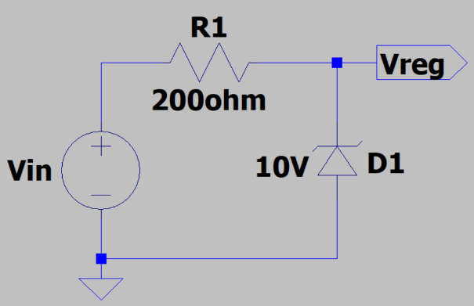
- Determine the maximum input voltage to the adjacent voltage regulator circuit that does not exceed the 0.5 W maximum power rating of the Zener diode. (2 points.)

$$P_{Z}=I_{z}V_{z}$$
$$I_{z}{=\frac{P_{Z}}{V}}_{z}$$
$$I_{Z}=I_{R1}=\frac{V_{in}-10}{200}=\frac{P_{Z}}{V_{Z}}$$
$V_{in}=200\left(\frac{P_{Z}}{V_{Z}}\right)+10 = 200 Ω\left(\frac{0.5W}{10V}\right)+10V$=20V
$$V_{in_max}=20V$$

V_{in_max} = $20V$

- Zener diodes are special silicon pn junction diodes, designed to provide a non-destructive, well controlled, breakdown voltage. Zener diodes operating in their reverse breakdown region behave like an ideal voltage source in series with a relatively small resistance, resulting in a fairly constant reverse biased diode voltage for a wide range of diode currents.

Connect up the circuit illustrated below in Figure 1. For the 1N5234 6.2 V breakdown voltage Zener diode, first place a Zener diode from the main LTspice library, referred to as zener. LTspice does not have a 1N5234 Zener diode model, so an external model needs to be included in your schematic using a .model statement. First change the Zener diode type from D to D1N5234. Next on the Edit pull-down menu in the upper left-hand corner of the LTspice window, choose Spice Directive, which opens up an edit pane in which to paste the following model information on your schematic for the 1N5234 Zener diode:
.model D1N5234 D(Is=1.536f Rs=1.687 Ikf=0 N=1 Xti=3 Eg=1.11
+Cjo=130p M=.5259 Vj=.75 Fc=.5 Isr=1.719n Nr=2 Bv=6.2 Ibv=1.9685
+Nbv=.28384 Ibvl=7.0094e-7 Nbvl=.29418 Tbv1=443.55u)

Next on the Edit pull-down menu in the upper left-hand corner, choose Spice Analysis which opens up an Edit Simulation Command pane. Set the DC Sweep parameters as follows: .dc Vs -7 1 0.01, which sweeps the independent voltage source Vs from -7 V to 1.0 V in 10 mV increments. In the Edit pull-down menu, add your name to your schematic as follows: Edit Text. When completed with your schematic, replace the schematic shown in Figure 1 below with your version, including your name. (6 points.)

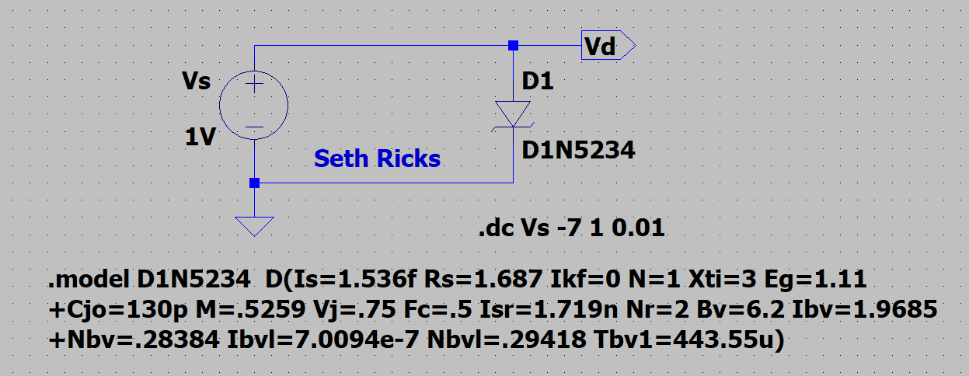
Figure 1: LTspice Circuit for Characterizing the 1N5234 Zener Diode.

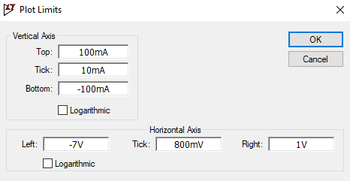
After running the simulation, a Plot Pane will open in which you are to select the waveform I(D1) for display. Next limit the diode current axis in the plot pane as follows: Go to Plot Settings Manual Limits, which opens a Plot Limits pane as shown below to be used to set the vertical axis limits at -0.1 A to 0.1 A in 10 mA divisions.

Figure 2: LTspice Plot Limits Pane.
Note: LTspice uses a dark background for the default plot pane, which makes it hard to visibly see some trace colors such as dark blue. The Tools Control Panel Waveforms Color Scheme Background allows you to modify the background color with Red = Green = Blue = 255 resulting in a white background. This is an optional change that you may find improves waveform viewing. If you make this change, it is also recommended to navigate to Tools Control Panel Waveforms and change the Data Trace and Cursor width from 2 to 3, along with using a Bold Font for the waveform labels so that the traces, cursors are waveform labels are more easily visualized.

Next attach both cursors to I(D1) and adjust one cursor to a V_{s} voltage of -6.2 V and the other cursor to a V_{s} voltage of 0.7 V. Both the mouse and the left and right arrow keys can be used to move the waveform cursors along a given trace. Then drag the cursor pane onto your plot to document your diode current values as illustrated in the figure below. Finally, in the Plot Settings pull-down menu on the main LTspice toolbar, annotate your plot with your name as follows: Plot Settings Notes & Annotations Place Text. Replace the plot pane shown in Figure 3 below with your version, including your name, along with the cursor pane indicating diode currents. (6 points.)
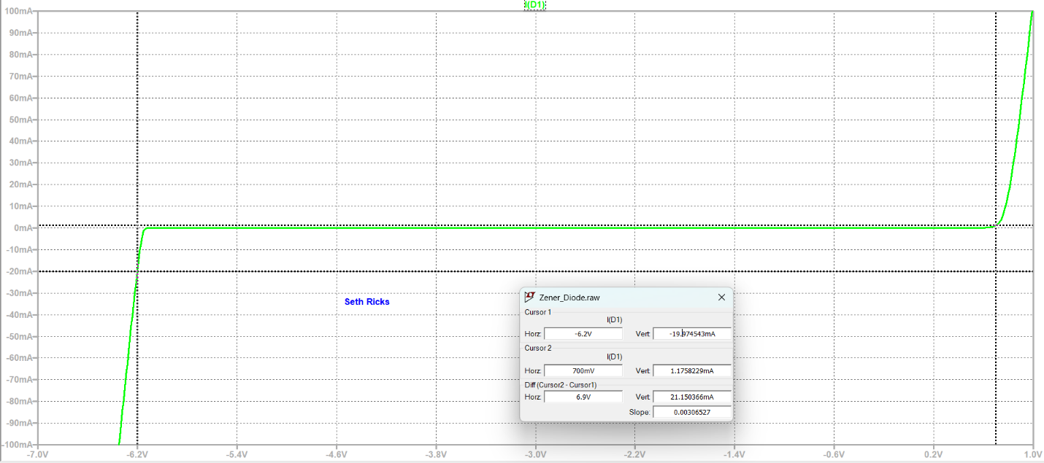
Figure 3: I-V Characteristics of an 1N5234 6.2 V Zener diode.

